TOAL ACTIVE POWER [MW] WeatherType Present

0 0.024284 Weather_Broken clouds 0

1 0.037689 Weather_Broken clouds 0

2 0.037689 Weather_Broken clouds 0

3 0.037689 Weather_Broken clouds 0

4 0.037689 Weather_Broken clouds 0  
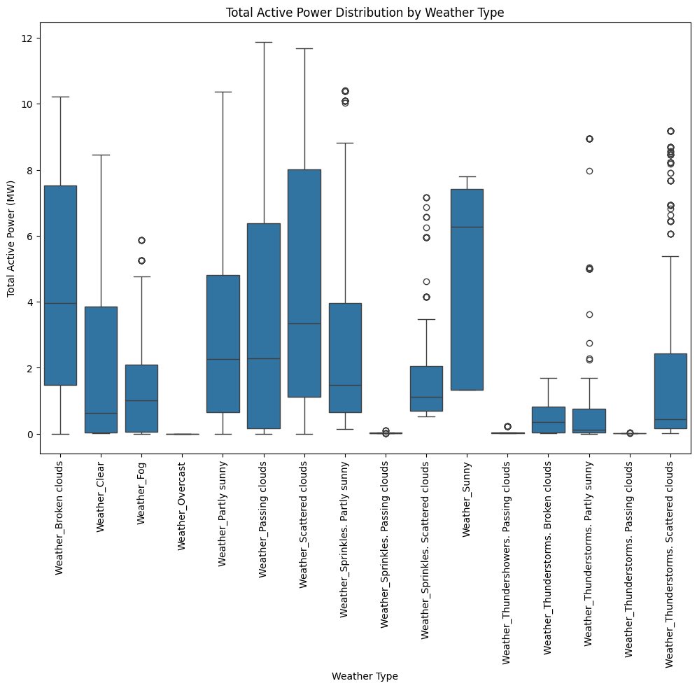

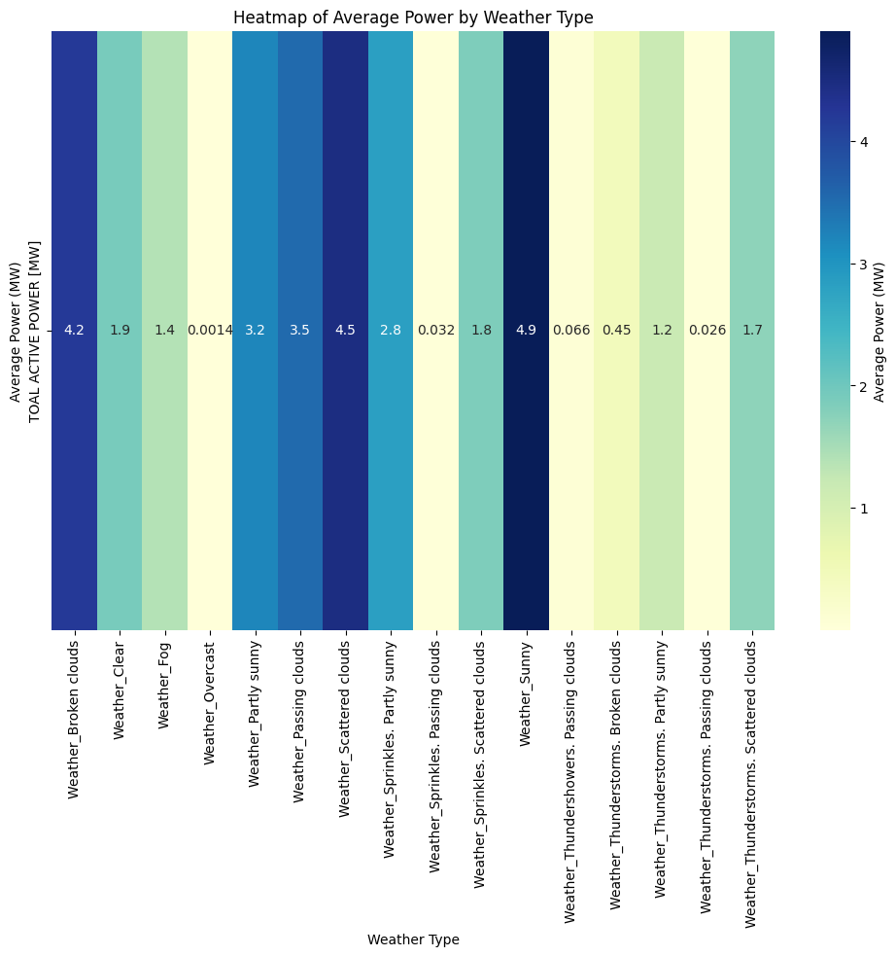

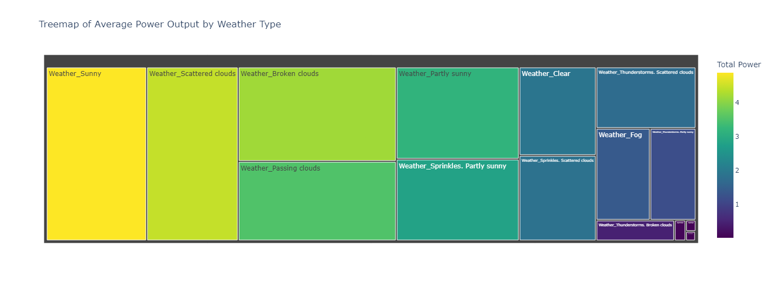

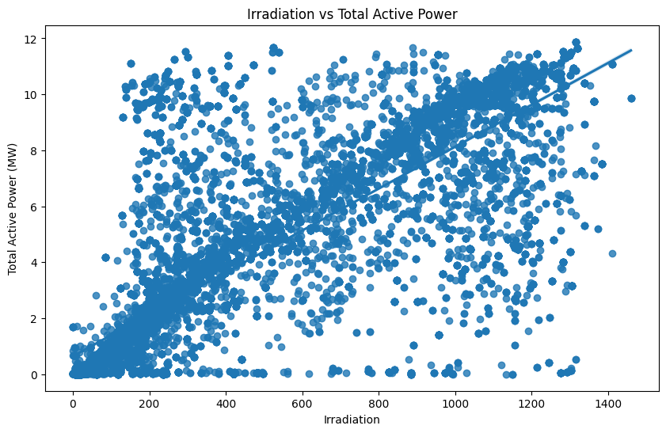

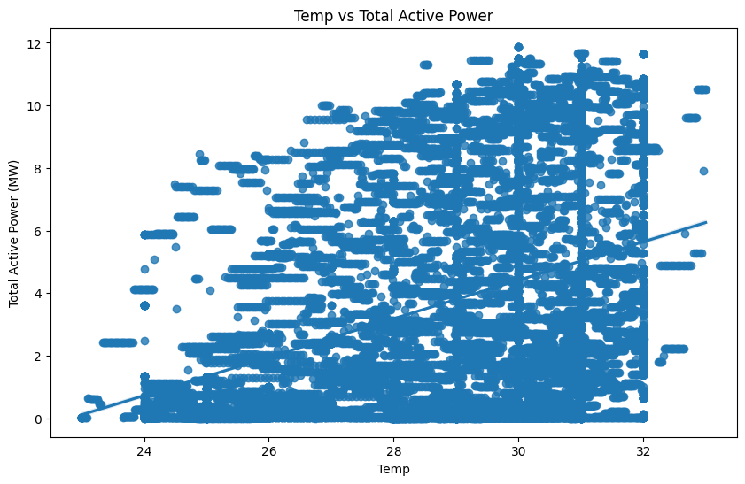

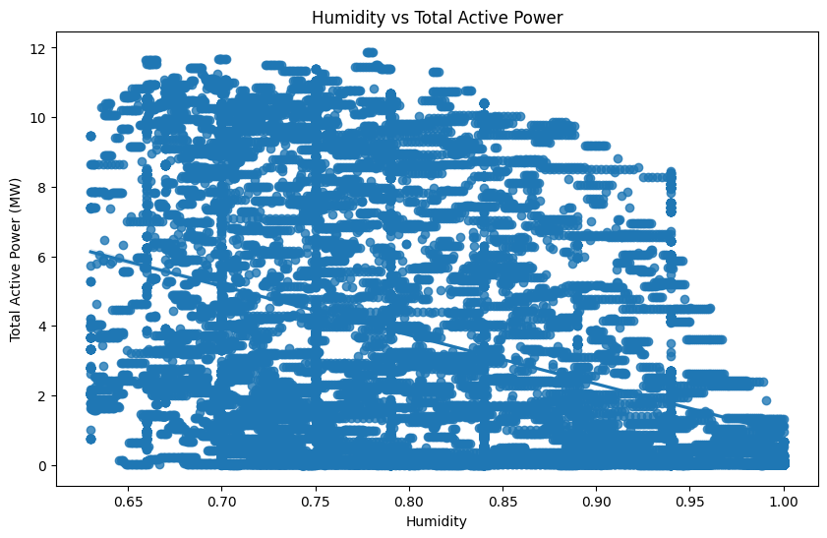

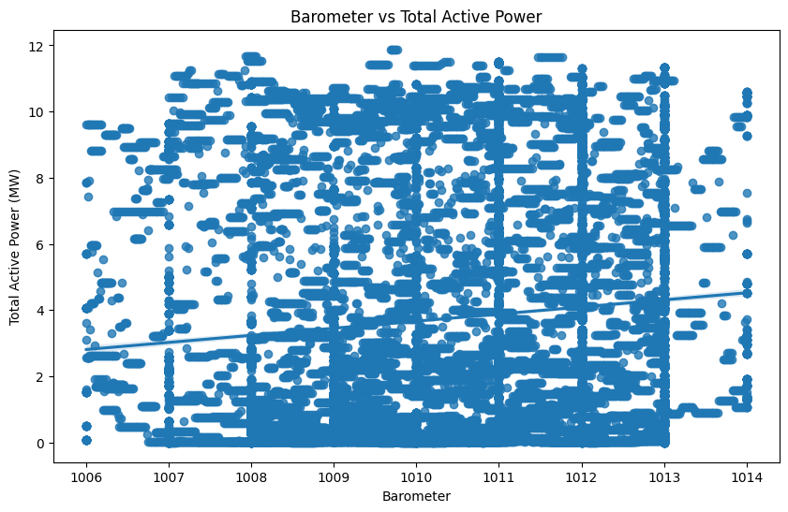

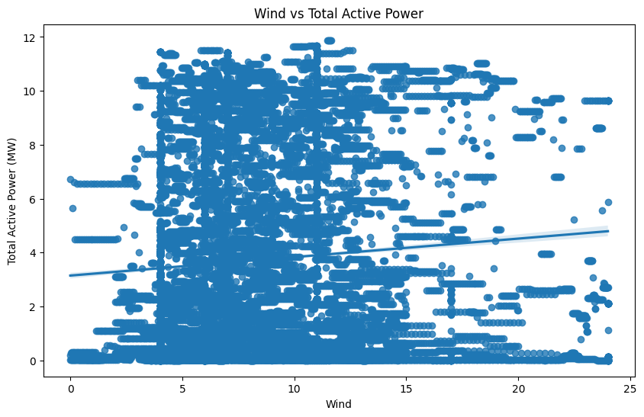

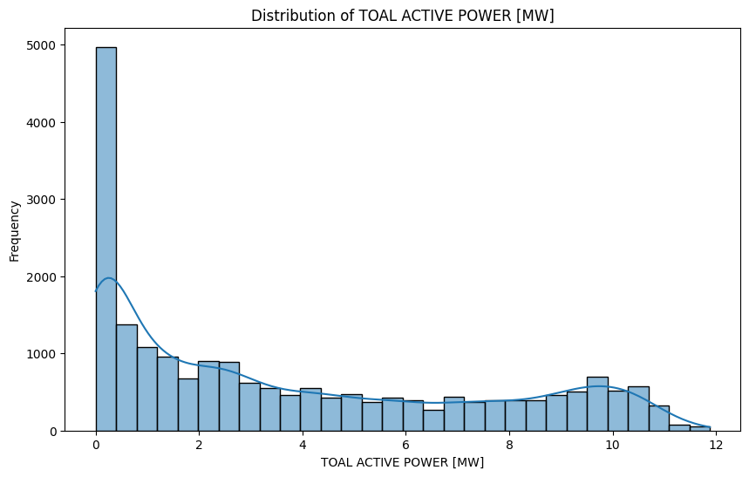

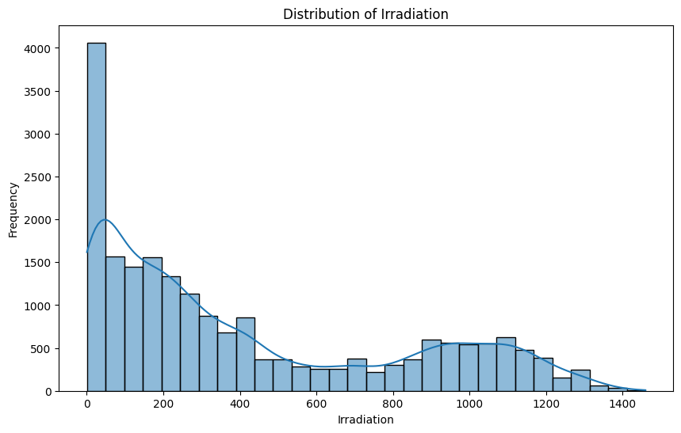

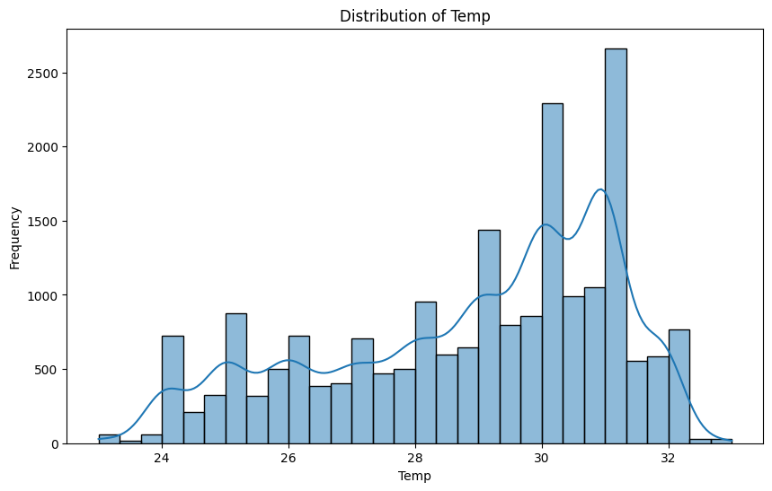

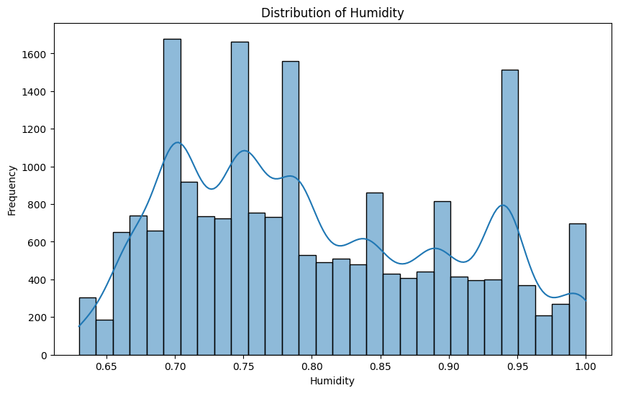

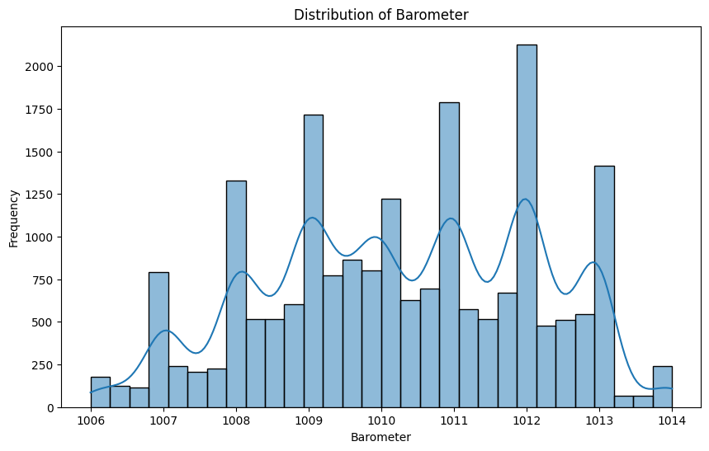

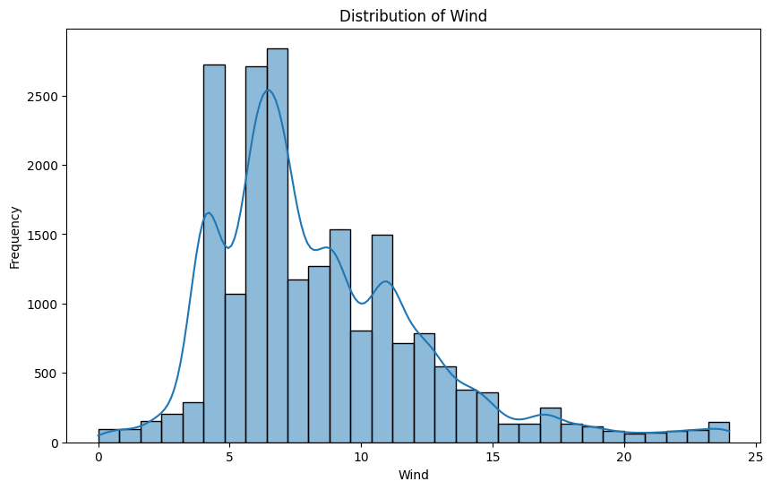

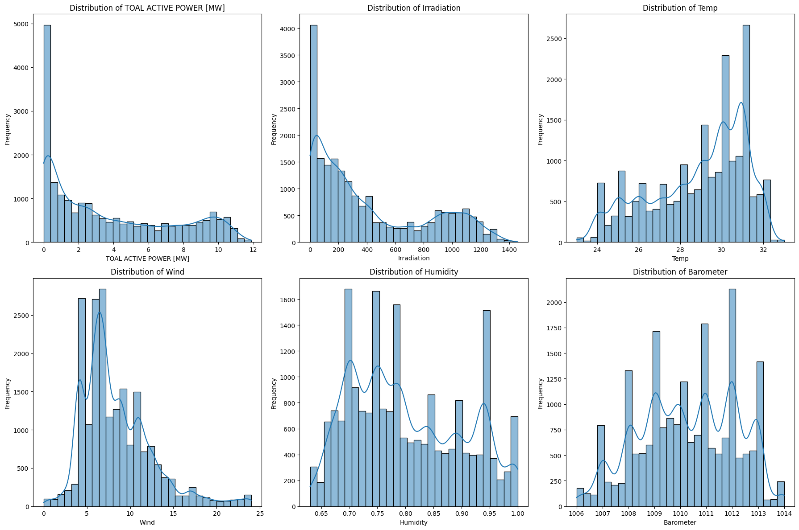

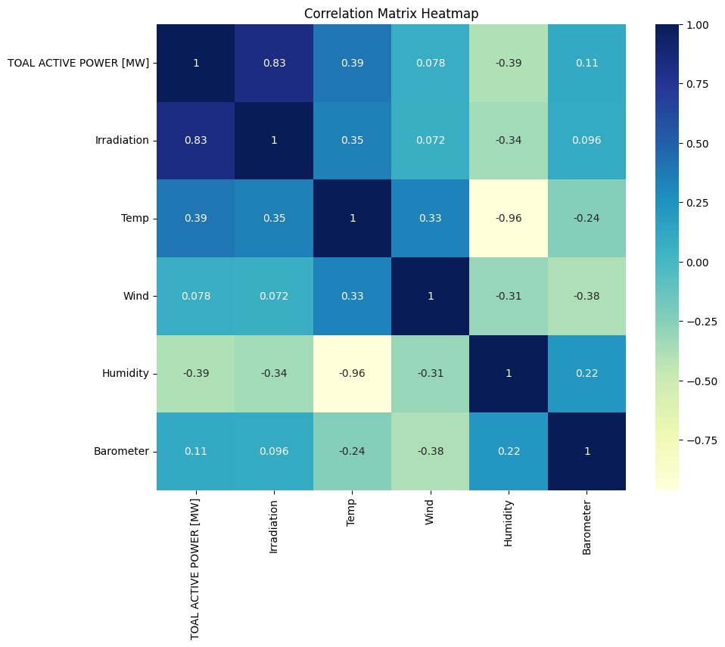

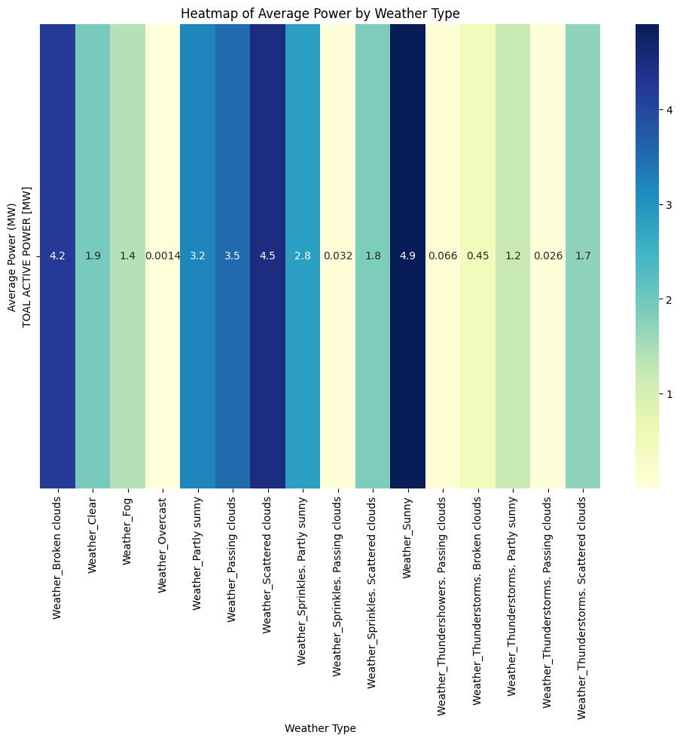

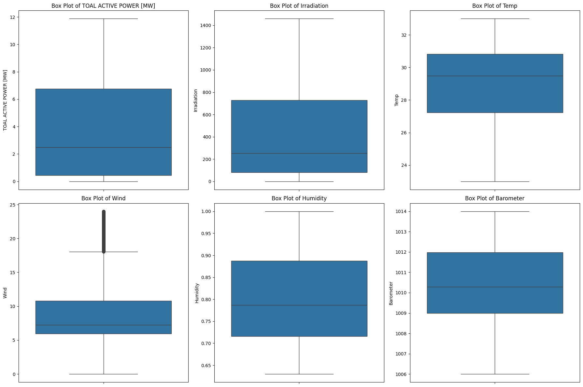

Humidity 4.012542

Barometer_lag_2 1.456868

Temp_lag_2 0.143862

Wind_lag_2 0.014226

Temp 0.012391

Irradiation 0.005444

Wind_lag_1 0.003575

Irradiation_lag_2 0.001739

Irradiation_lag_1 0.000020

Barometer_lag_1 -0.007155

Wind -0.015747

Temp_lag_1 -0.019869

Humidity_lag_1 -0.273595

Barometer -1.316227

Humidity_lag_2 -5.047022

dtype: float64

